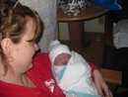 Gram with Derren Jacob Romo Born: April 3, 2011 (4 wks early)
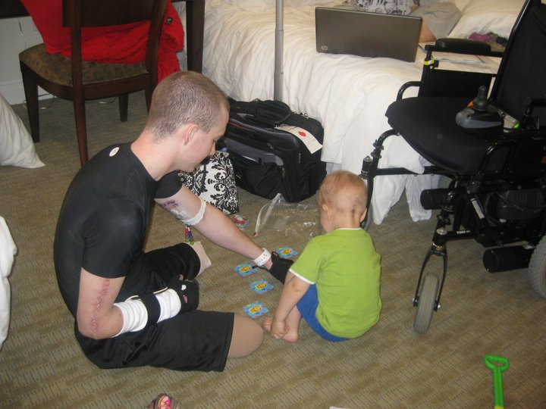

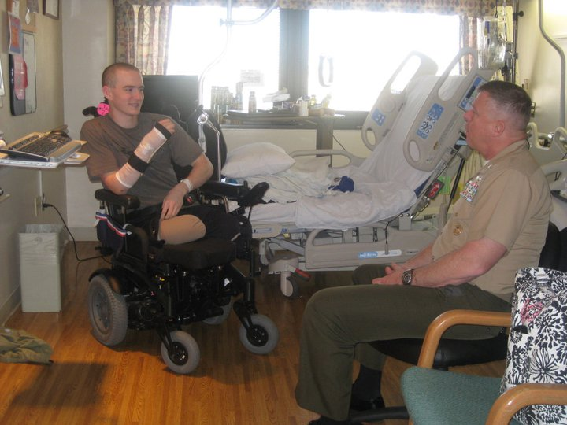
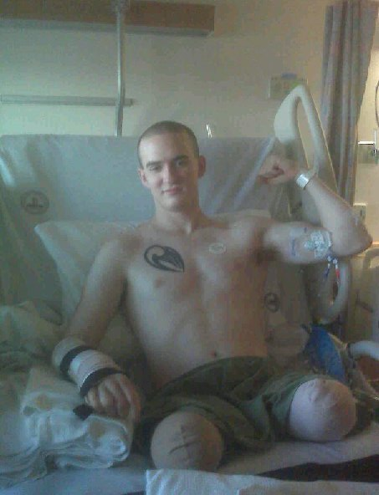
Jake before leaving Bethesda for Balboa, CA
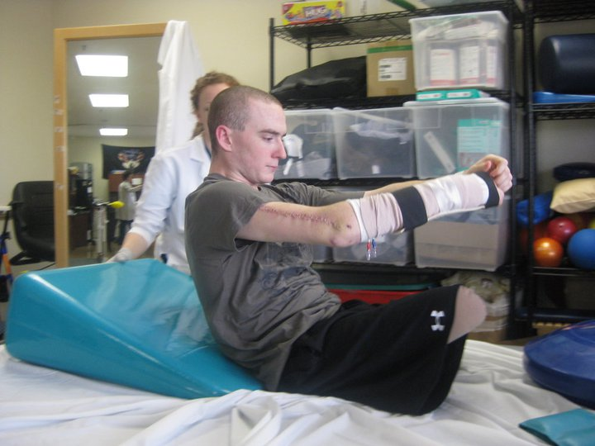
Jake in Physical Therapy

